**Assignment-3**

**Question 1 -**

**Write the queries for the following tasks –**

**1.Create a database name – “Employee”**

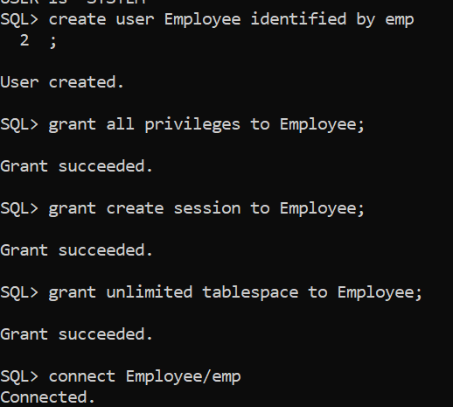

I have created a user/database with name as Employee and have granted all privileges to the Employee user. I have created a session role and granted it to the Employee user. To create a table I have used the command “grant unlimited tablespace to Employee”, which gives access to add a table in the local user.

**2. Create a table name - “Employee Details”.**

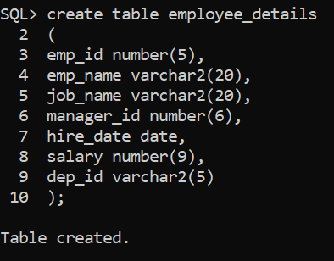

I have created a table with name “employee_details” and added column names in the schema.

Used the command**:“desc employee_details”** to show the schema of the table.

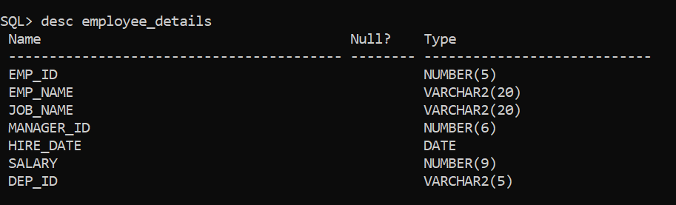

**3. Insert 10 details in employee_details table**

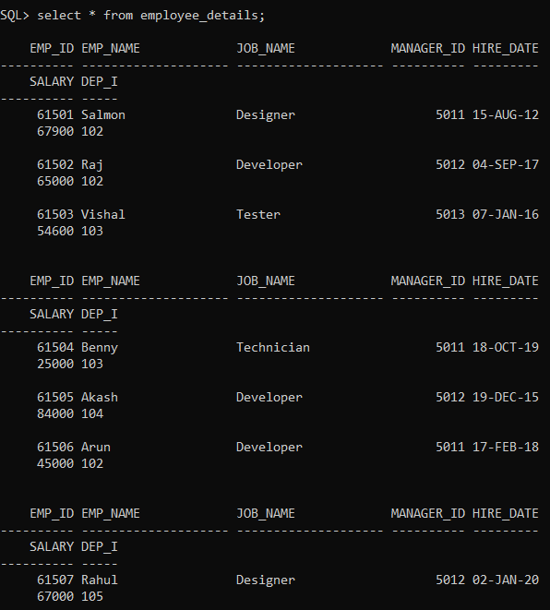

Insert ten rows with emp_id, emp_name, manager_id, hire_date, salary and dep_id as column names by using the following command:

insert into table_name values(val1,val2..);

or

insert into table_name values(&col1,&col2,&col3….);

Here I have used the following command:

**insert into employee details values(&emp_id,&emp_name,&job_name,&man_id,&hdate,&sal,&d_id);**

To display all the details of the employee I have used the command:

**“select * from employee_details”**

**4. Find the salaries of all the employees form “Employee_details” table**

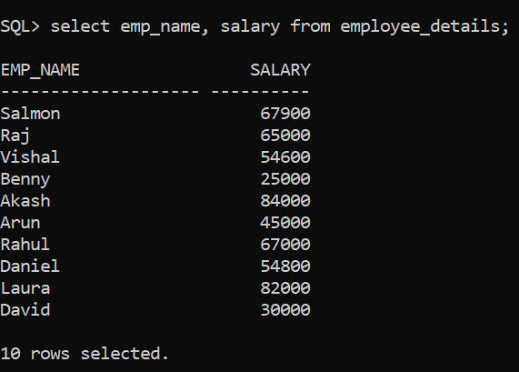

Fetched the salary of all the employees in the database by using the command:

**“select emp_name ,salary form employee_details”**

**5.Find the unique designations of the employees from the table**

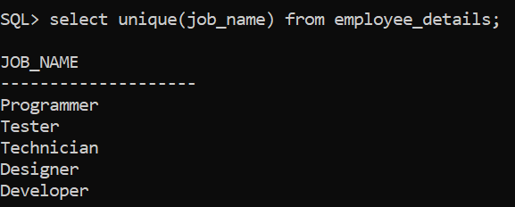

Here to identify the unique designations I have used the command:

**“unique(col_name)”**

To display them I have used the command:

**“select unique(job_name) form employee_details”**

**6. Change the salary where the emp_name is “Raj”**

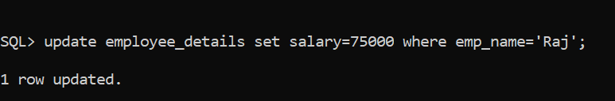

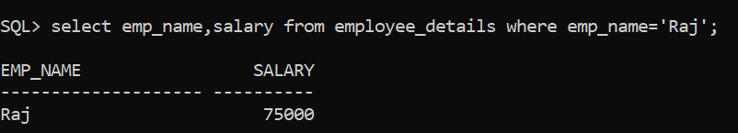

Update is the command to modify the existing data in the table

Command: **“update employee_details set salary=75000 where emp_name=’Raj’;**

**Question 2 -**

**Write the queries for the following tasks –**

**1.Create a database name - “Football”.**

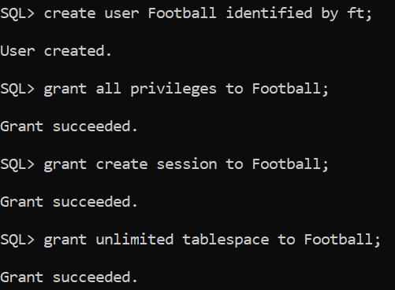

Create the user with name “Football” and granted all the privileges

**2. Create a table name “Football_venues”**

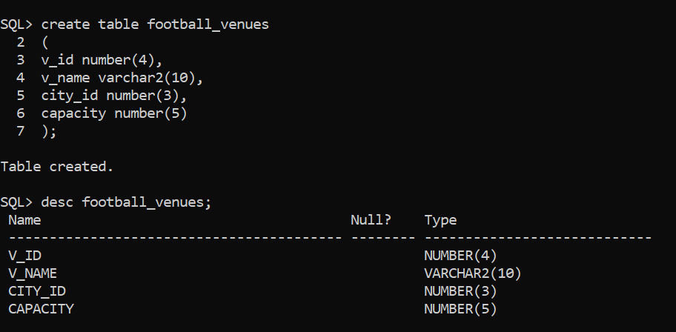

Created a table with name “Football_venues” and used the command **“desc table_name”** to describe the structure of the table

Command to create table: **“create table table_name( col1 datatype, col2 datatype, …)”**

**3. Insert 10 details in the “Football Venue” table**

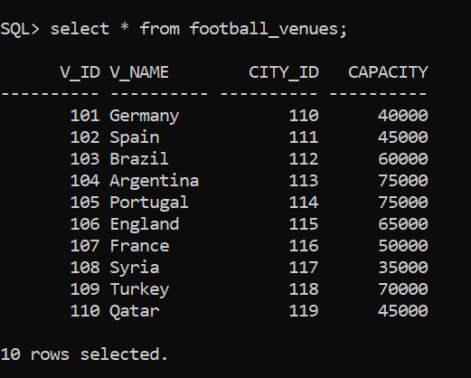

Inserted values into the table by using the command: **“insert into table_name values(&col1,&col2..)”**

Here I have used : **insert into football_venues values(&v_id,&v_name,&city_id,&capacity);**

**4.** **Count the number of venues of the football world cup**

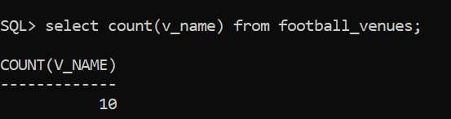

Count is the command to find the number of columns created

Command**: “count(col_name)”**

**5.** **List all the venue names and capacities in the format of “Location” and “Volume”.**

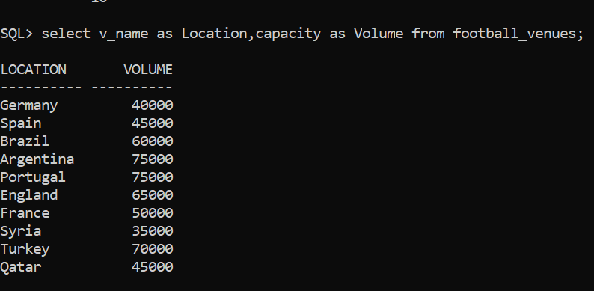

“as” is the command used to represent a column name with another name

Command**: “select v_name as Location, capacity as Volume from football_venues”**

**6.** **Delete all the details where venue_name is equal to “Australia”**

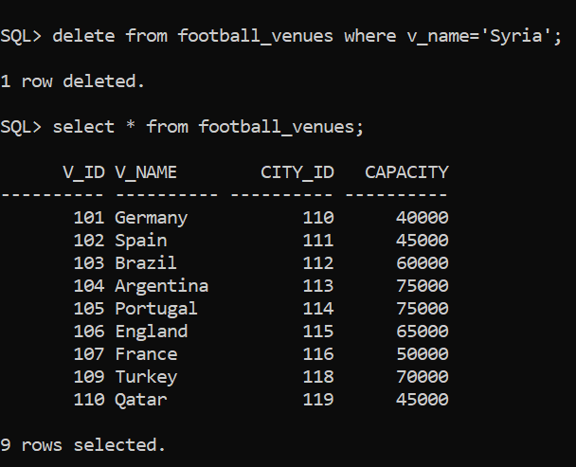

**“Delete” is the command used to remove any column or row based on a particular condition: “delete from football_venues where v_name=’Syria’;**

**Note: Used venue name as ‘Syria’ as there is no venue with name as ‘Australia in my table**